Module 2
Assessment Questions:
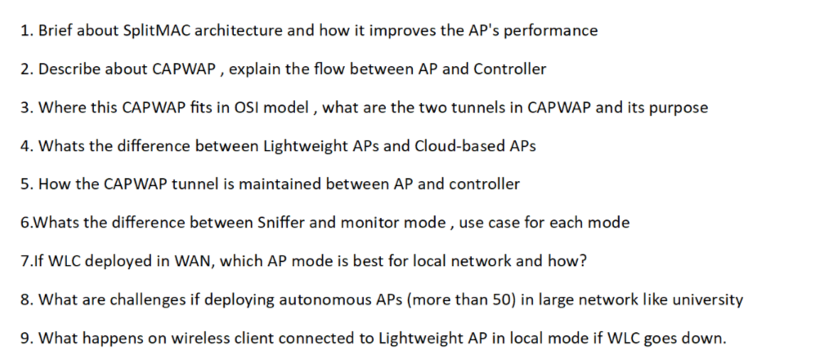

Answers :

1. Brief about Split MAC Architecture and How It Improves AP Performance

Introduction
In enterprise wireless networks, Access Points (APs) are usually lightweight devices managed by a centralized Wireless LAN Controller (WLC). This architecture is called Split MAC because the Medium Access Control (MAC) functions are divided between the AP and the controller.

MAC Layer Responsibilities
The MAC layer handles wireless communication tasks such as:
- Frame transmission
- Acknowledgments
- Encryption and decryption
- Authentication
- Roaming
- Association management
In Split MAC, these responsibilities are divided intelligently.

Functions Performed by AP
The AP handles all time-sensitive, real-time operations:
- Sending Beacon frames
- Responding to Probe Requests
- Frame acknowledgments (ACKs)
- Encryption and decryption
- Retransmissions
- RF signal transmission and reception
These tasks require immediate action and cannot tolerate network delay.

Functions Performed by WLC
The WLC handles centralized tasks:
- User authentication
- Security policy enforcement
- VLAN assignment
- Roaming decisions
- QoS policies
- RF management
- Configuration management

Why Split MAC is Needed
Wireless communication requires some decisions to be made within microseconds. If every decision had to travel to the controller, latency would increase significantly.
Split MAC ensures:
- Fast local decisions at AP
- Centralized intelligence at WLC

Performance Improvements

Reduced Processing Load
The AP focuses only on radio operations.

Faster Response
Critical wireless frames are processed instantly.

Better Scalability
A single controller can manage hundreds of APs.

Simplified Management
Administrators configure policies once on the controller.

Seamless Roaming
WLC coordinates client movement between APs.

Real-World Example
When a client sends a data frame:
- AP immediately acknowledges the frame.
- AP encapsulates it in CAPWAP.
- WLC applies security and forwarding policies.
This division ensures both speed and centralized control.

2. Describe CAPWAP and Explain the Flow Between AP and Controller

What is CAPWAP?
CAPWAP stands for:
Control And Provisioning of Wireless Access Points
It is the protocol used by lightweight APs to communicate with the Wireless LAN Controller.

Purpose of CAPWAP
- AP discovery
- Controller join
- Configuration download
- Firmware updates
- Traffic tunneling
- Monitoring and management

CAPWAP Ports
- UDP 5246 – Control Tunnel
- UDP 5247 – Data Tunnel

Complete AP-to-WLC Flow

Step 1: AP Bootup
- AP powers on.
- Performs POST.
- Loads operating system.

Step 2: IP Address Acquisition
- AP obtains IP address via DHCP.
- Also receives subnet mask, gateway, and DNS.

Step 3: WLC Discovery
Methods include:
- DHCP Option 43
- DNS query (CISCO-CAPWAP-CONTROLLER)
- Broadcast (same subnet)
- Previously saved controller IP
- Manual configuration

Step 4: Controller Selection
- AP selects the best available WLC.
- Priority rules are applied.

Step 5: DTLS Handshake
- AP and WLC authenticate each other using certificates.
- Secure tunnel is established.

Step 6: Join Request
- AP sends Join Request.
- WLC validates AP credentials.

Step 7: Configuration Download
- WLC sends:
  - WLAN configurations
  - SSIDs
  - Security settings
  - RF parameters

Step 8: Firmware Verification
- If versions mismatch, WLC upgrades AP.

Step 9: Tunnel Establishment
- Control tunnel created.
- Data tunnel created.

Step 10: Operational State
- AP starts broadcasting SSIDs.
- Clients can now connect.

3. Where CAPWAP Fits in OSI Model, What Are the Two Tunnels and Their Purpose

OSI Layer Placement
CAPWAP operates at:
- Layer 7 – Application Layer
It uses UDP at Layer 4.

Transport Details
- UDP Port 5246 – Control
- UDP Port 5247 – Data

Two CAPWAP Tunnels

1. Control Tunnel

Purpose
Carries management traffic between AP and WLC.

Information Transferred
- Join messages
- Configuration updates
- Keepalive packets
- Statistics
- Radio information
- Authentication exchanges

Security
- Protected using DTLS encryption.

2. Data Tunnel

Purpose
Carries actual client traffic.

Information Transferred
- Client data packets
- DHCP requests
- DNS traffic
- Internet traffic

Operation
- AP encapsulates wireless frames into CAPWAP.
- Sends them to WLC.

Why Two Separate Tunnels?
- Better security.
- Simplified troubleshooting.
- Independent management.
- Efficient traffic handling.

4. Difference Between Lightweight APs and Cloud-Based APs
Feature | Lightweight AP | Cloud-Based AP
Management | Local WLC | Cloud Portal
Controller | On-Premises | Cloud Hosted
Deployment | Campus Networks | Branch Offices
Internet Dependency | Low | High
Scalability | Moderate | Excellent
Maintenance | Manual | Automated

Lightweight AP

Characteristics
- Depends on WLC.
- Uses CAPWAP.
- Centralized control.

Best For
- Large enterprise campuses.
- Low-latency environments.

Cloud-Based AP

Characteristics
- Managed through cloud dashboard.
- No physical controller required.

Best For
- Retail chains.
- Remote offices.
- Distributed enterprises.

Key Difference
- Lightweight AP uses on-prem controller.
- Cloud AP uses internet-hosted controller.

5. How CAPWAP Tunnel Is Maintained Between AP and Controller

Keepalive Mechanism
AP and WLC periodically exchange:
- Echo Request
- Echo Response
This confirms connectivity.

DTLS Session
- Security session remains active.
- Encryption keys are maintained.

Sequence Number Monitoring
- Detects packet loss.
- Ensures proper packet order.

Tunnel Health Monitoring
- Latency checks
- Packet loss checks
- Retransmission monitoring

Failure Detection
If multiple keepalives are missed:
- Tunnel considered down.
- AP enters recovery mode.

Reconnection Process
- AP restarts discovery.
- Rejoins primary or backup controller.

6. Difference Between Sniffer Mode and Monitor Mode, Use Cases

Sniffer Mode

Purpose
Captures wireless packets for analysis.

Features
- Forwards captured packets to analyzer.
- Works with Wireshark.
- Detailed packet inspection.

Use Cases
- Authentication failures
- Roaming issues
- Performance troubleshooting
- Protocol analysis

Monitor Mode

Purpose
Monitors RF environment continuously.

Features
- Scans all channels.
- Detects threats.
- Identifies interference.

Use Cases
- Rogue AP detection
- Wireless IDS/IPS
- Security monitoring
- Interference analysis

Comparison Table
Aspect | Sniffer | Monitor
Packet Capture | Yes | Limited
Security Detection | Basic | Advanced
Wireshark Support | Yes | No
Client Service | No | No

7. If WLC Is Deployed in WAN, Which AP Mode Is Best and How?

Best Choice: FlexConnect

Why FlexConnect?
- Local data switching.
- Centralized management.
- WAN bandwidth savings.

Working

Control Traffic
- Sent to central WLC.

Client Data
- Switched locally at branch switch.

Benefits
- WAN optimization.
- Better application performance.
- Survivability during WAN outage.

WAN Failure Scenario
- Existing clients continue working.
- Local authentication possible.
- Local switching continues.

Ideal Use Cases
- Branch offices
- Remote campuses
- Retail stores

8. Challenges of Deploying Autonomous APs in Large Networks

Major Challenges

1. Manual Configuration
Each AP requires separate setup.

2. Inconsistent Policies
Security settings may vary.

3. Difficult Roaming
No centralized mobility management.

4. Firmware Management
Updates must be applied individually.

5. Complex Troubleshooting
No single management interface.

6. Scalability Issues
Managing 50+ APs becomes impractical.

7. RF Coordination Problems
Channel and power planning become difficult.

8. Security Risks
Higher chance of misconfiguration.

Conclusion
Autonomous APs are suitable only for small deployments.
Large environments require controller-based architecture.

9. What Happens When WLC Goes Down for Lightweight AP in Local Mode?

Immediate Effect
- CAPWAP tunnel disconnects.

Existing Clients
- Usually lose connectivity.
- Data forwarding stops.

New Clients
- Cannot join network.
- Authentication fails.

AP Behavior
- Stops receiving controller instructions.
- Attempts to discover backup WLC.

Recovery Options

Primary/Secondary WLC
- AP joins alternate controller automatically.

HA SSO
- Near-zero downtime.

Important Note
In Local Mode:
- Both control and data traffic depend on WLC.
Therefore, controller failure directly impacts service.

Exception
If using FlexConnect with local switching:
- Existing clients may continue working even if WLC becomes unreachable.

